Nathaniel Gee

Professor Ryan

CS 110

December 13th 2020

CS 110 Final Project Report

**Section One; “Overview and Summary of Project”:**

My program was designed to understand the performance of non-alcoholic drink companies throughout the summer of the pandemic in 2020. To do this my code graphs the closing prices for Coca-Cola, Pepsi, and Nestlé who are big companies in the non-alcoholic drink industry. My code graphs the data from these three companies starting from June 2nd 2020 to September 29th 2020. The program allows you to either examine the performance of just one company out of the three, compare two companies out of the three, or compare all three of the companies at once. It does this by asking the user to enter in a whole number from 1 to 7. Based on that input the program will show a graph that corresponds with the chosen number. For example, as shown in the image below, entering the number 5 will graph a chart that shows PepsiCo’s and Nestlé performance so one can compare the two companies.

User Interface:

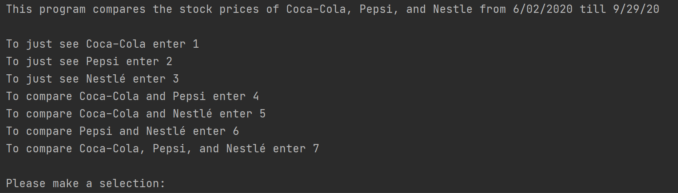

If the user inputs “5” it will graph both PepsiCo and Nestlé

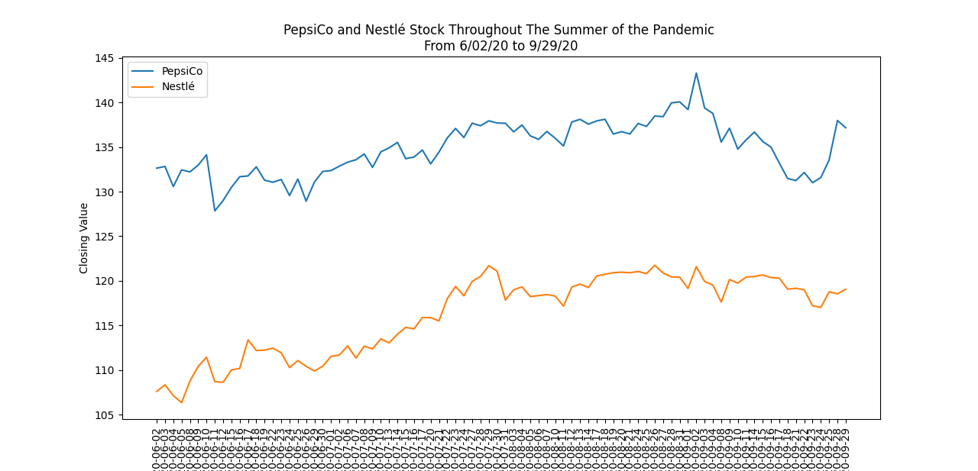

**Section Two; “Target Audience”:**

Someone who might use this program might be an investor who is thinking about investing in the consumer staples sector. More specifically someone who is trying to invest in the non-alcoholic beverage industry might use this program to see how major players in the industry held up during the summer of the pandemic. The major players typically indicate how the industry as whole is performing in general. So, this program can also give an investor a sense on how the industry was impacted by COVID-19 pandemic. In addition, if one is considering investing in either Coca-Cola, Pepsi, or Nestlé they can use this program to compare the historical performances of each stock.

**Section Three; “Specific Programming Techniques Used”:**

At the top of my program is “import csv” and “import matplotlib. pyplot as plt”. These two packages allow for the csv files of each stock to be open, read, and plotted as a graph. I also used four lists and each there is a combination of the stock’s csv files’ path list. Each list was used for a different function as some functions only graphed two stocks so it ran the list that had the file path for those two specific stocks. The main component of my code is the functions. I have seven functions, and each one displays a different graph. Three functions only display one of the stocks, three display two stocks, and the last function displays all three stocks. In my main function I have a menu that allows the user to select which stock or stocks they want graphed. In the main function I also used try, if and except statements to make sure that a valid input was given and let the user know when an invalid input was given. I also used a flag by setting “selection = False”. This meant that the program would keep asking the user for a valid input and only when a valid input was chosen then selection would equal true and continue to run the program. Finally, I used an if-elif statement to let the program know which function to call based on the input given by the user.

**Section Four; “Challenge(s)”:**

One major challenge I ran into was setting up the functions. I knew how to program code to run all the files at one time, however I had trouble adjusting the code to only graph two out of the three stocks. To fix this problem I created a new list, and in the new list they only had the file path for two out of the three stocks. Then for each function that was meant to graph only two stocks I would call upon the list that only had the file path for those two specific stocks. I also had trouble keeping the program running when an invalid input was given. To fix this I add the “selection = False” flag in the program to keep prompting the user until a valid input was given.

**Section Five; “Future Extensions”:**

One way to improve the program would be the obvious of comparing more stocks in the non-alcoholic beverage business. I know that there are finance packages that can get the historical data for a company by just giving the ticker symbol. This could improve the program and allow the user to choose which stocks they want to see graphed. In addition to improving on this program in the future I would add an option that allows the user to graph the S&P 500 or graph an ETF that tracks consumer staples. By doing this the user can get a better idea of how Coca-Cola, PepsiCo, and Nestlé performed relative to the market or their sector.